SNAPSHOTS:

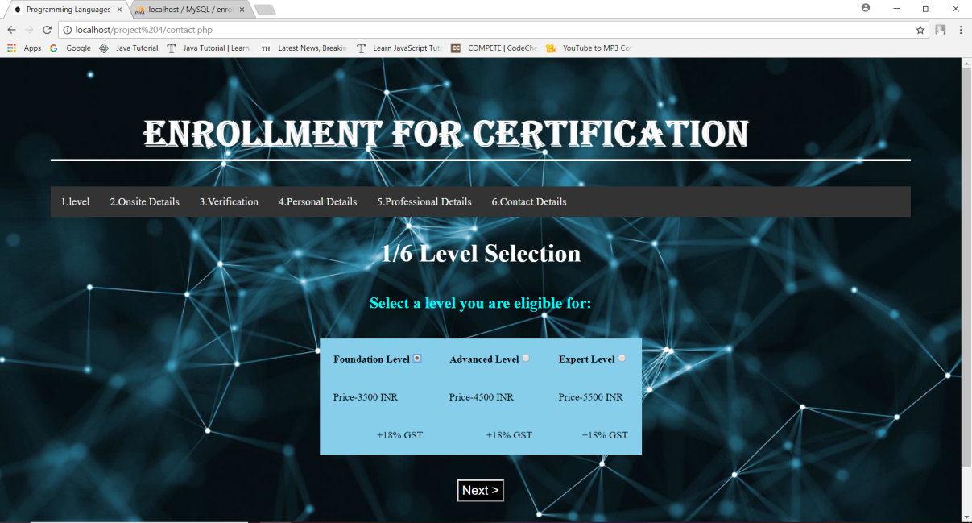

This is the first page of the student enrollnment system.Here the user choses his level that he/she is eligible for.Then the user goes to the next page for chosing date and city of examination.

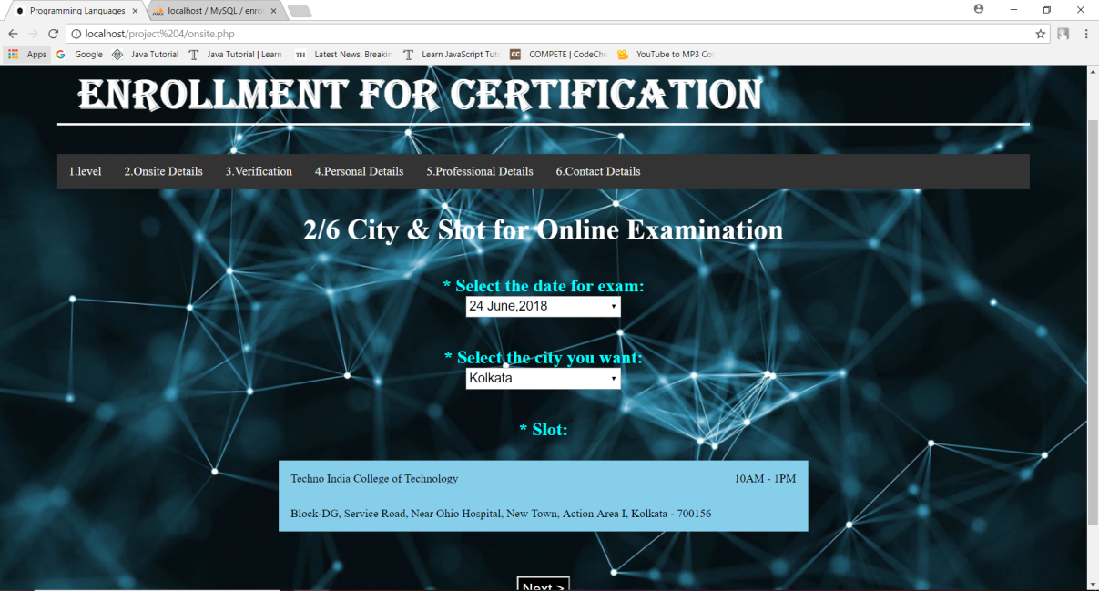

On this page the user is required to chose the date and city of examination .According to the city of examination the center of examination will be provided from the database. The user then clicks on the next button for verifying government ID.

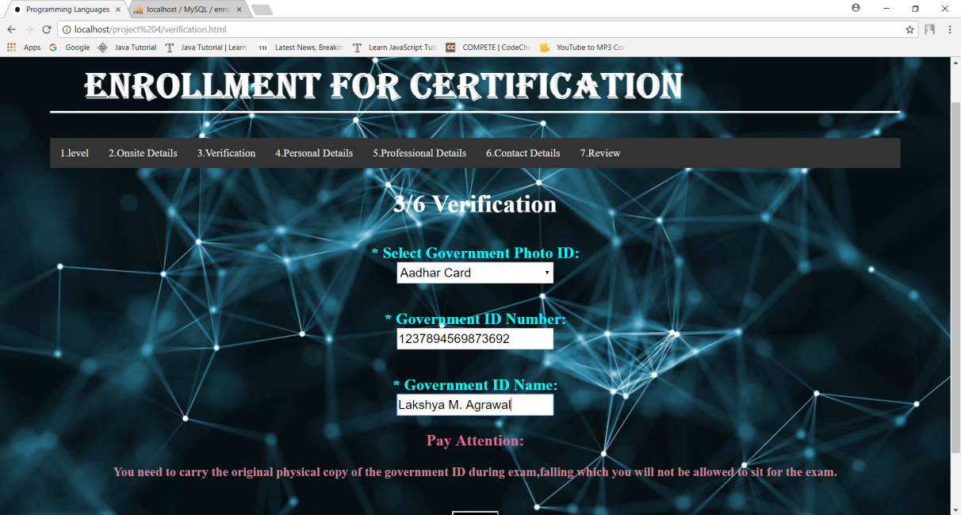

Here on this page the user is required to verify any one of its government ID numer and name as mentioned on the government ID.The user then clicks on the next button to provide his personal details.

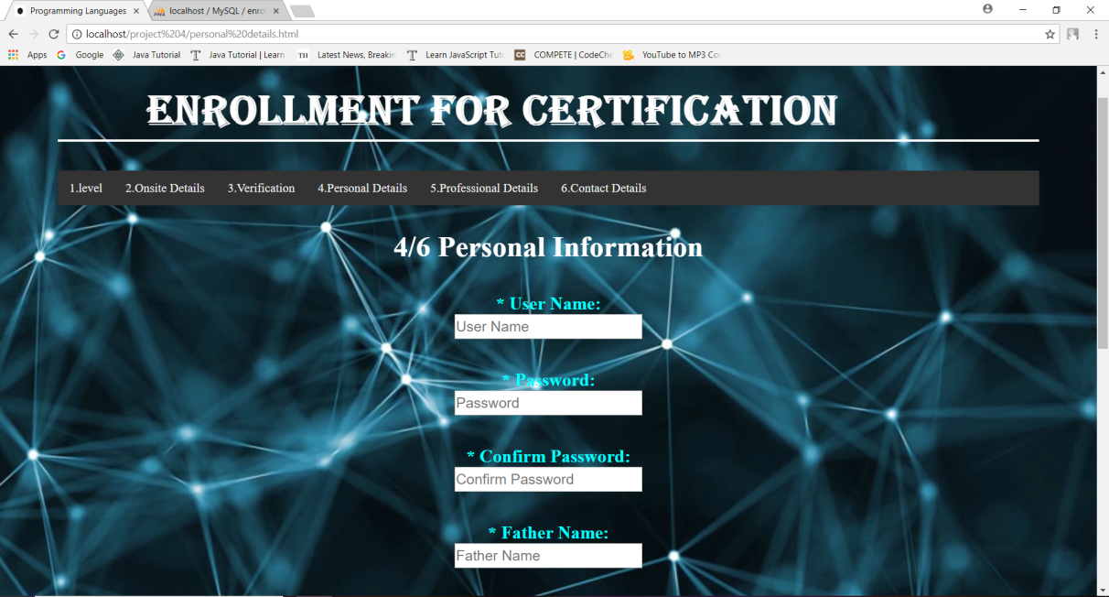

Here the user is required to fill his personal details like father name, mother name, gender and chose his username and password.The user then clicks on next button to provide his professional details.

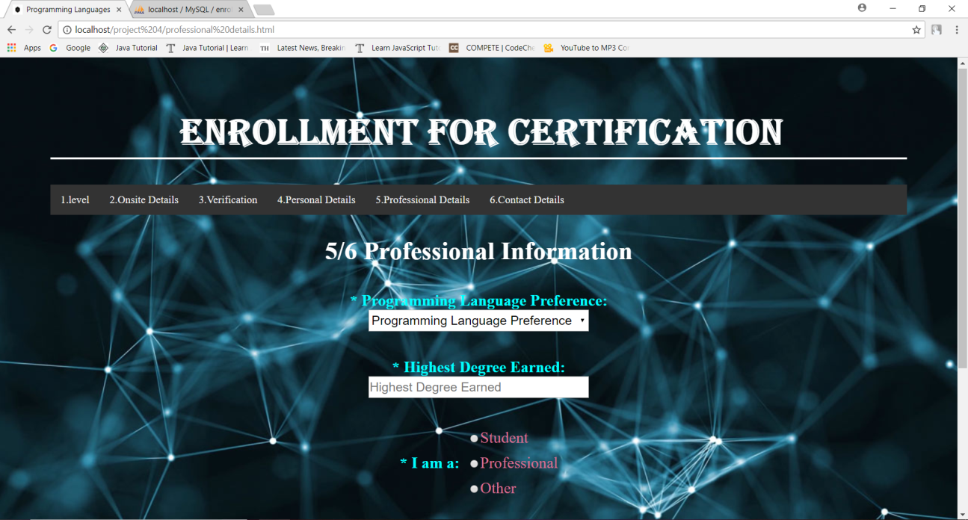

On this page the user is required to provide his professional information and chose the programming language for which he wants certification.The user then clicks on the next button to provide his contact details.

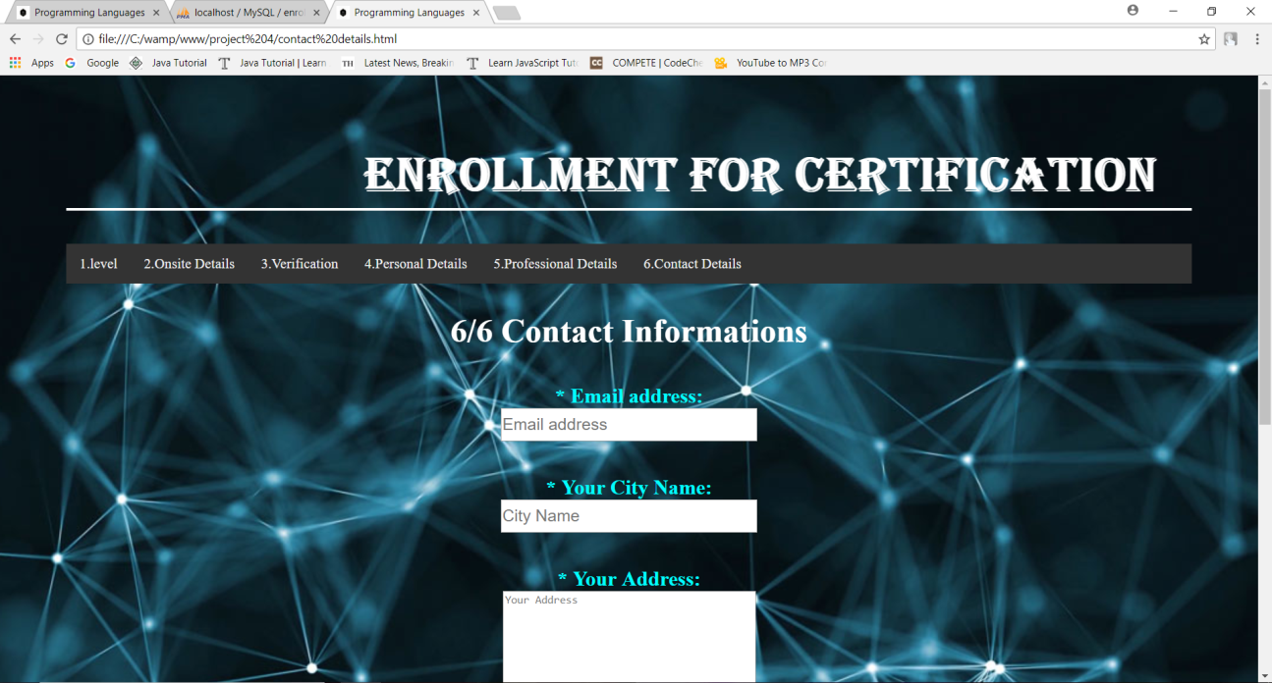

On this page the user is required to provide his contact information like Email, city name and address and then on clicking the submit button the data is stored in the database. All the user details will be stored page by page.